19/03/2024
Mergin Exercise
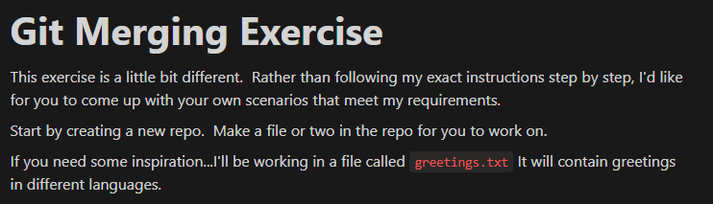
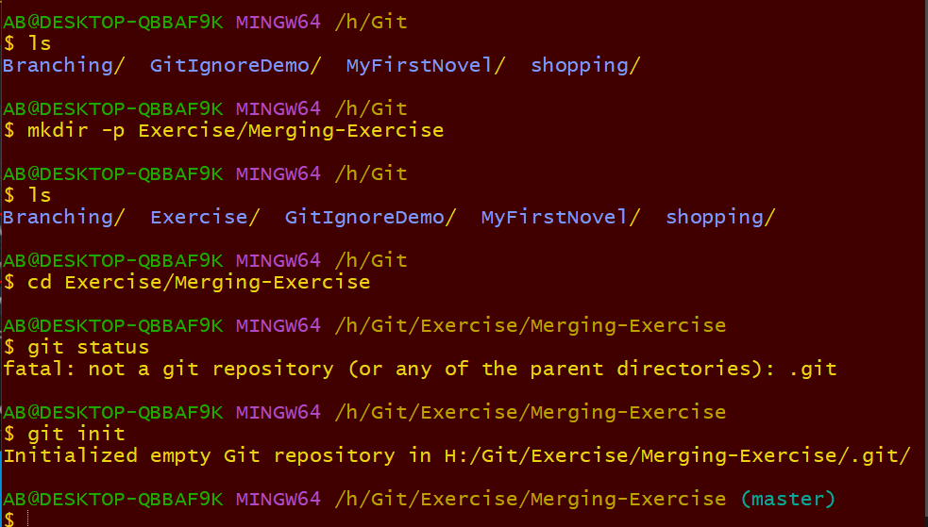

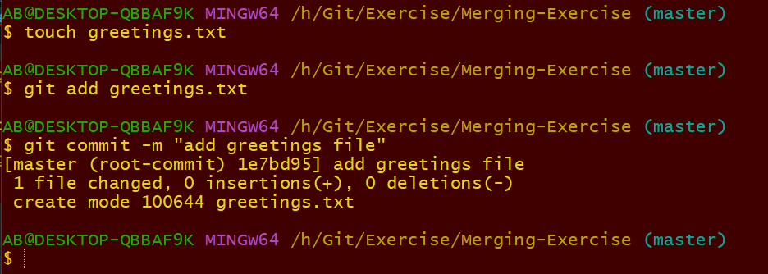
I made this on master and committed it.
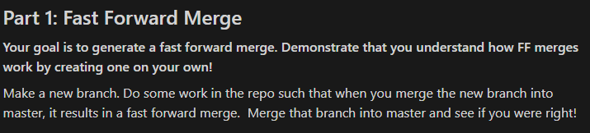
I will create another branch and so that I can merge it into the master branch
I don’t tough master again. I can have several branches if I like.
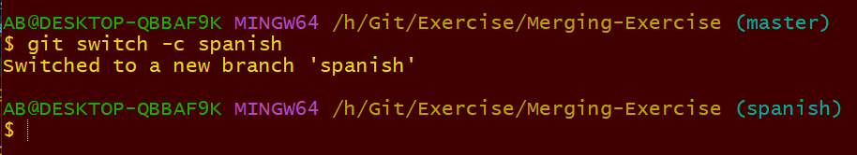
I can have several commits on Spanish if I like. I will not touch master in the mean time.
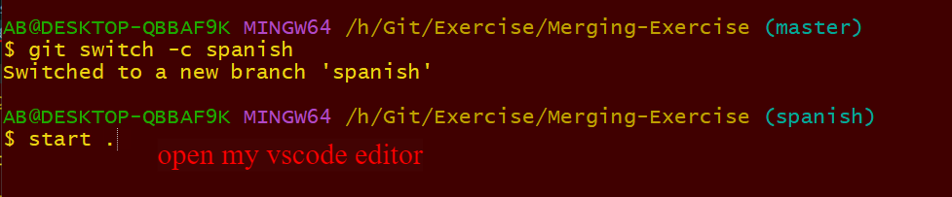
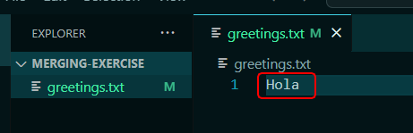
I added that in the file.
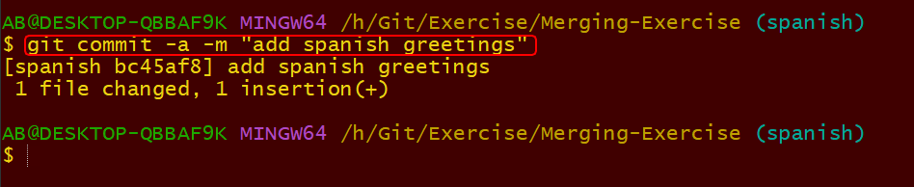
I commit the Spanish greetings
Now I want to merge the Spanish into master. I need to switch to master.
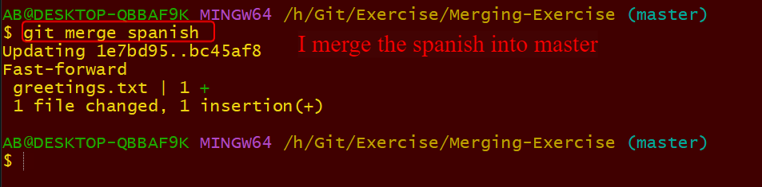
Or whatever name of your branch name. This is called fast forward merge. Remember you could have 10 commits or more. What matter is that the master that I merge into did not change in the mean time.
The 2nd one.
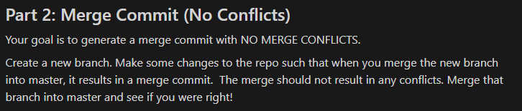
To generate a merge commit I need to make a commit on master branch.
I need to have a new branch and also make commits inside that branch before merging into master.
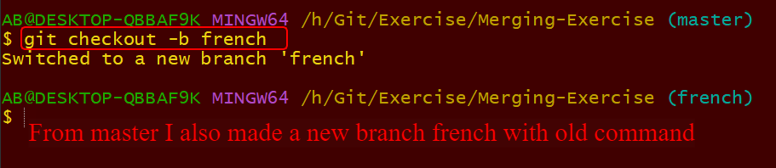
Remember all this will still display to the same greetings file on master so far I have not created a new file on master.
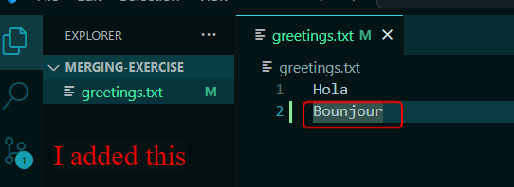
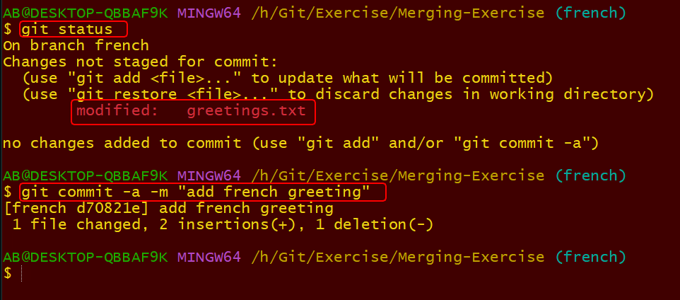
I added something inside the file and commit it on French branch.
I will not merge it yet because if I did it will be fast forward merge.

Go back to master.
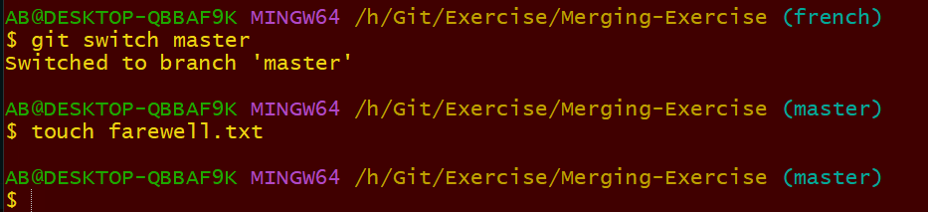
I switched to the master and created a new file called farewall.txt
Inside the firewall.txt I added goodbye as you can see below.
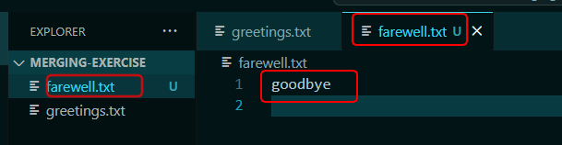
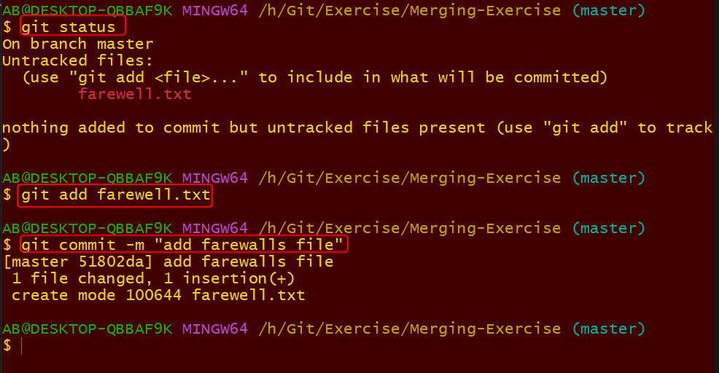
If you’re adding or committing any file on the master for the first time you need to use manual command rather than using all shortcut command. I commit the new file on the master.
Now I have a commit on master branch that does not exit on the French branch
I also have a commit on French branch that does not exit on master branch. I should not have any conflicts as those commit does not overlap.
I have one commit on a different file called firewall.txt
I also have another commit on greetings file. Even if there are on the same file there might not be conflicts.
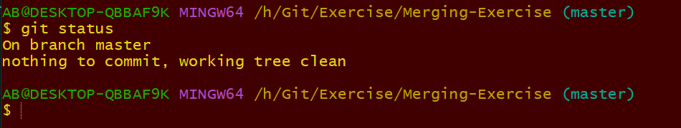
Checking before I merge.
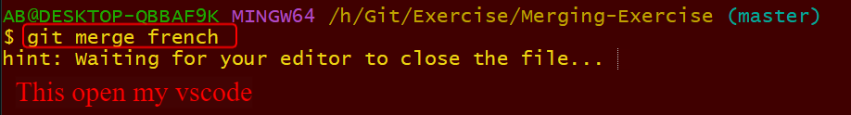
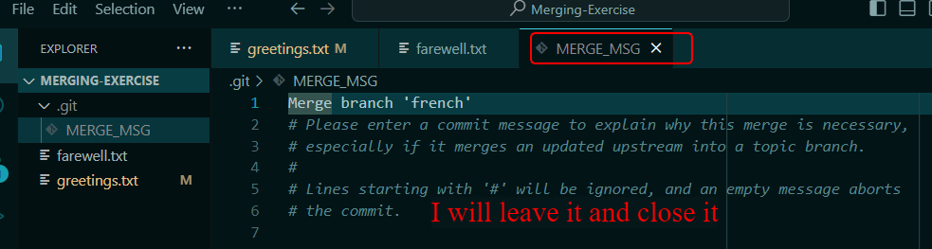
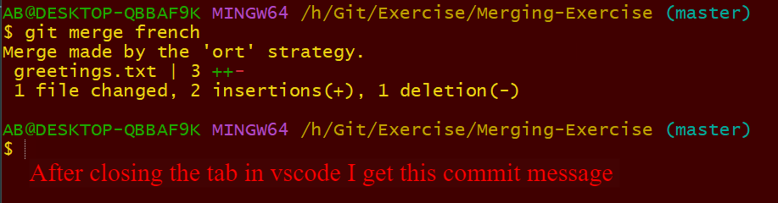
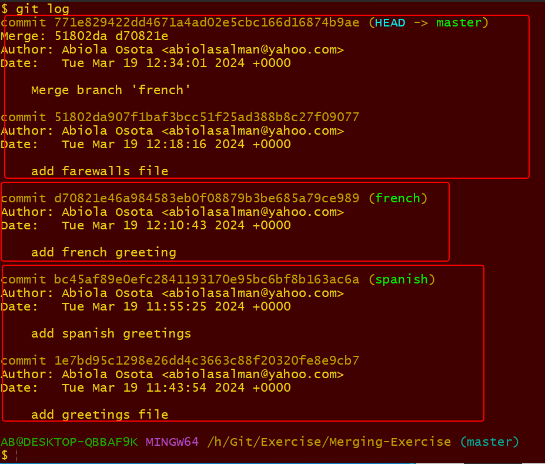
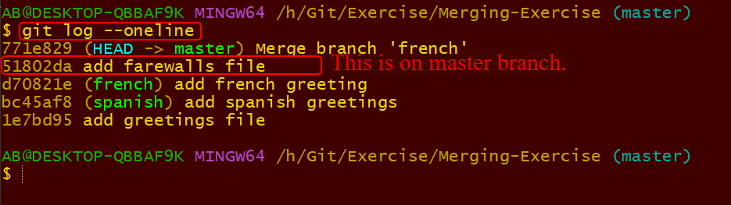
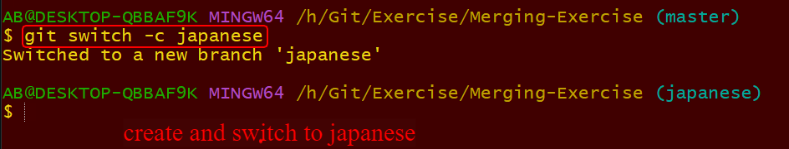

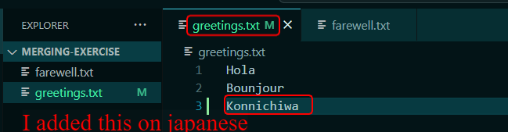
This was added on Japanese branch
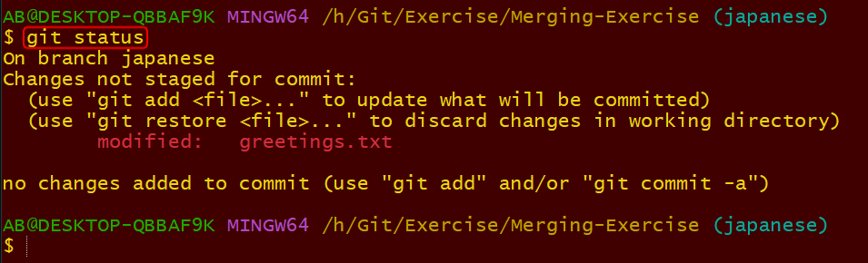
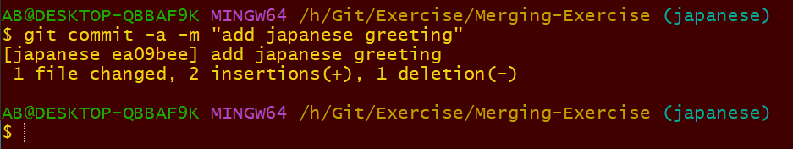
Committed file on Japanese after I have added few things inside the greetings file.
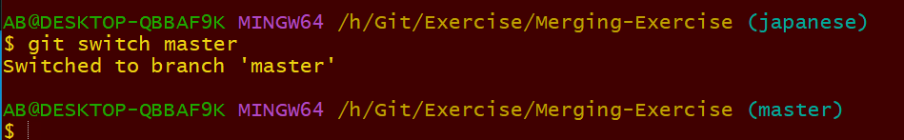
Before I do any mergin I will do changes to greeting.
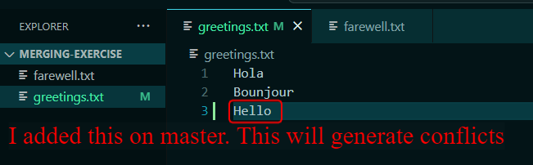
Because I just updated the same line on Japanese.
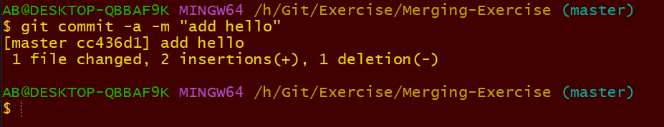
When I want to merge will get conflict.
If I merge it will generate conflit as the Japanese line has an update that is similar to the master line also
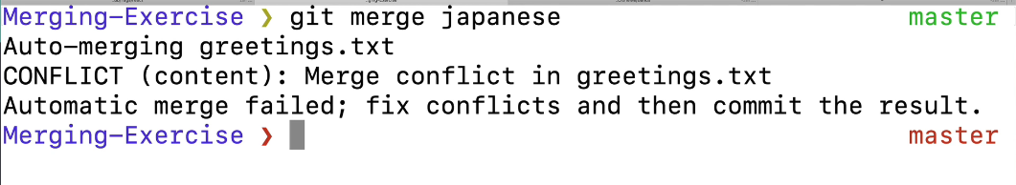
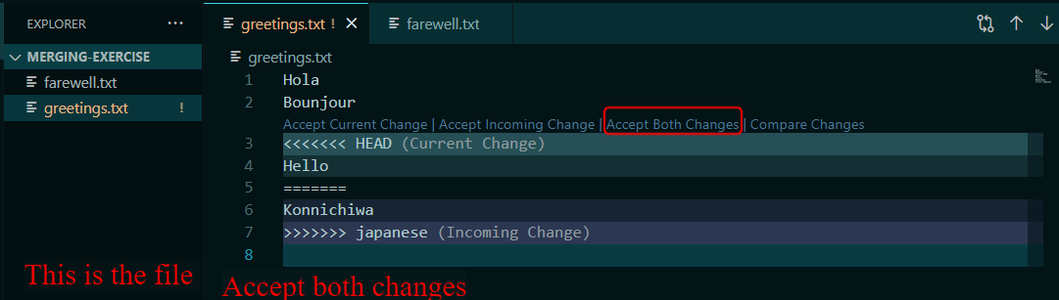
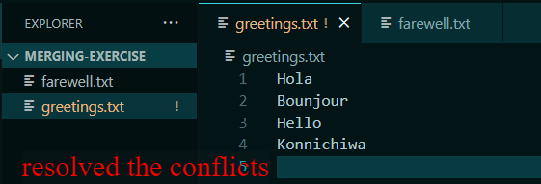
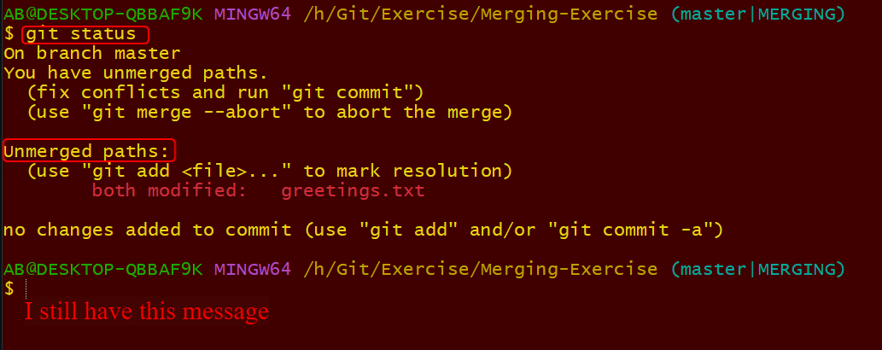
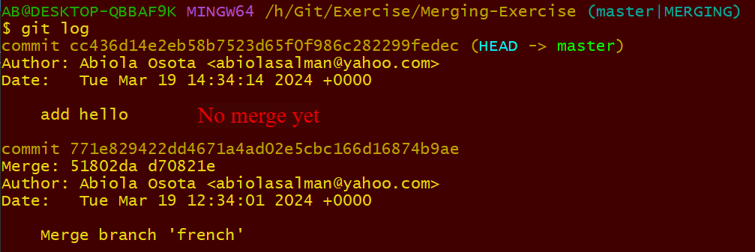
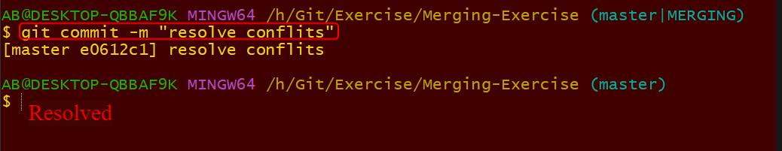
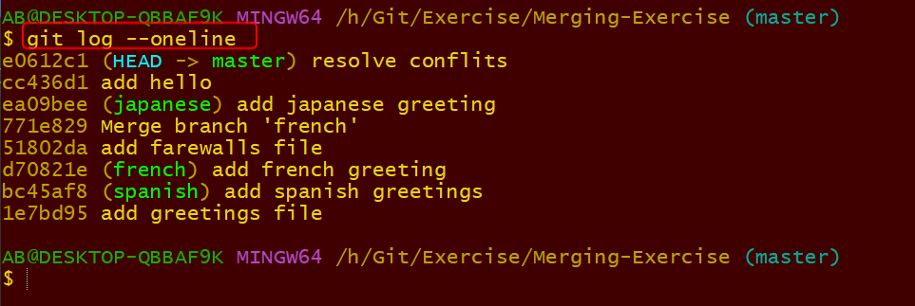
Resolved

